Behavioral and Topological Heterogeneities in Network Versions of  
Schelling’s Segregation Model

Will Deter and Hiroki Sayama

Center for Collective Dynamics of Complex Systems  
Department of Systems Science and Industrial Engineering  
Binghamton University, State University of New York  
[wdeter1@binghamton.edu](mailto:wdeter1@binghamton.edu), [sayama@binghamton.edu](mailto:sayama@binghamton.edu)

**Abstract**

Agent-based network models of residential segregation have been of persistent interest to various research communities since their origin with Thomas Schelling. Frequently, these models have sought to elucidate the extent to which the collective dynamics of individuals’ preferences may cause segregation to emerge. This open question has sustained relevance in U.S. jurisprudence. Previous investigation of heterogeneity of behaviors (preferences) by Xie & Zhou (2012) has shown reductions in segregation on networks. Previous investigation of heterogeneity of topologies by Gandica, Gargiulo, & Carletti (2016) has shown no significant impact to observed segregation levels. Recent work by Sayama and Yamanoi (2020) has shown the importance of representing realistic heterogeneities in dynamical social network models. In this work, the necessity of concurrent representation of *both* behavioral and topological heterogeneities in network segregation models is examined. Extending the previous works, additional network simulations were conducted using both Xie & Zhou’s and Schelling’s preference models on 2D lattices with varied levels of densification to create topological heterogeneities (i.e., clusters, hubs). Results show a richer variety of outcomes, including novel differences in resultant segregation levels, fragmentation, and hub composition. Notably, with concurrent, increased representations of heterogeneous preferences and heterogenous topologies, reduced levels of segregation and fragmentation emerge. Implications and areas for future study are discussed.

Gandica, Y., Gargiulo, F., & Carletti, T. (2016). *Chaos, Solitons, and Fractals*, 90, 46-54.  
Sayama, H., & Yamanoi, J. (2020). *NetSci-X 2020 Proceedings*, pp. 171-181.  
Xie, Y., & Zhou, X. (2012). *PNAS*, 109(29), 11646-11651.

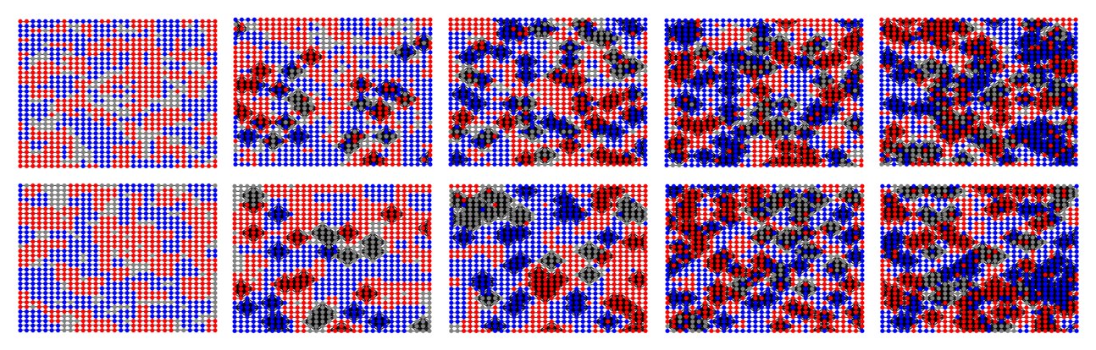

Figure 1: Sample final graph images for 0, 32, 64, 96, and 128 densifications (i.e., formation of clusters, or hubs). Top row: With Xie & Zhou preferences. Bottom row: With Schelling preferences. Blue and red nodes are individuals, grey nodes are vacancies.